**Advance Excel Assignment 16**

1. What is a Macro? How is it useful in excel or in your daily work?

Ans. Macro in Excel is a programming language used to automate tasks in Microsoft Excel. It helps users to automate repetitive tasks and create custom applications within Excel. It is a powerful tool that helps users to create complex calculations and automate tasks quickly and easily.

For Example:-

In case every month, we create a report for our accounting manager. we want to format the names of the customers with overdue accounts in red and apply bold formatting. we can create and then run a macro that quickly applies these formatting changes to the cells we select.

1. What is VBA? Write its full form and briefly explain why VBA is used in excel?

Ans. Full from of VBA is a **(Visual Basic Application).**

Visual Basic for Applications (VBA) is part of Microsoft Corporation's legacy software Visual Basic. VBA is used to write programs for the Windows operating system and runs as an internal programming language in Microsoft Office (MS Office, Office) applications such as Access, Excel, PowerPoint, Publisher, Word, and Visio. VBA allows users to customize beyond what is normally available with MS Office host applications.

VBA is an event-driven tool, which means that we can use it to tell the computer to initiate an action or string of actions. To do this, we build custom macros short for macroinstructions by typing commands into an editing module.

A macro is essentially a sequence of characters whose input results in another sequence of characters (its output) that accomplishes specific computing tasks.

Use of VBA in excel.

* Automation of Repetitive Task.
* Extending Scope of User Interaction.
* Interacting Between Office Applications.
* Creative way of doing things.

1. How do you record a macro? Write detailed steps to create a macro to automatically make the following table in bold and to create borders for it in excel.

Ans. The steps to record this macro:

* Click the Developer tab.
* In the Code group, click on the Macro button. This will open the ‘Record Macro’ dialog box.
* In the Record Macro dialog box, enter a name for the macro.
* In the ‘Store macro in’ option, make sure ‘This Workbook’ is selected. This step ensures that the macro is a part of the workbook.
* Click OK. As soon as we click OK, it starts to record the actions in Excel. We can see the ‘Stop recording’ button in the Developer tab, which indicates that the macro recording is in progress.
* Select cell A2.
* Enter the text Excel.
* Hit the Enter key. This will select cell A3.
* Click on the Stop Recording button in the Developer tab.

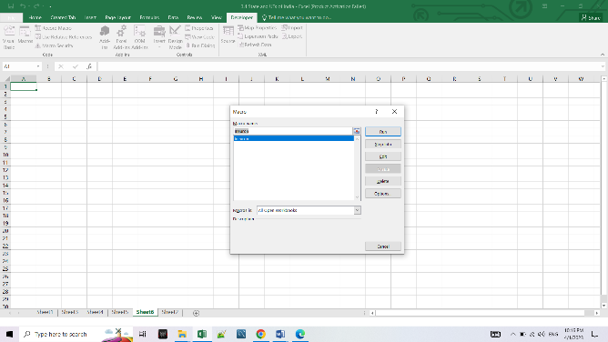 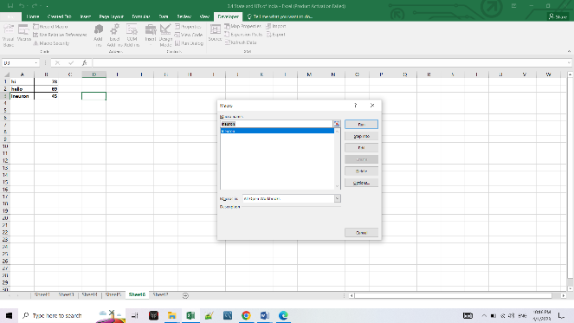

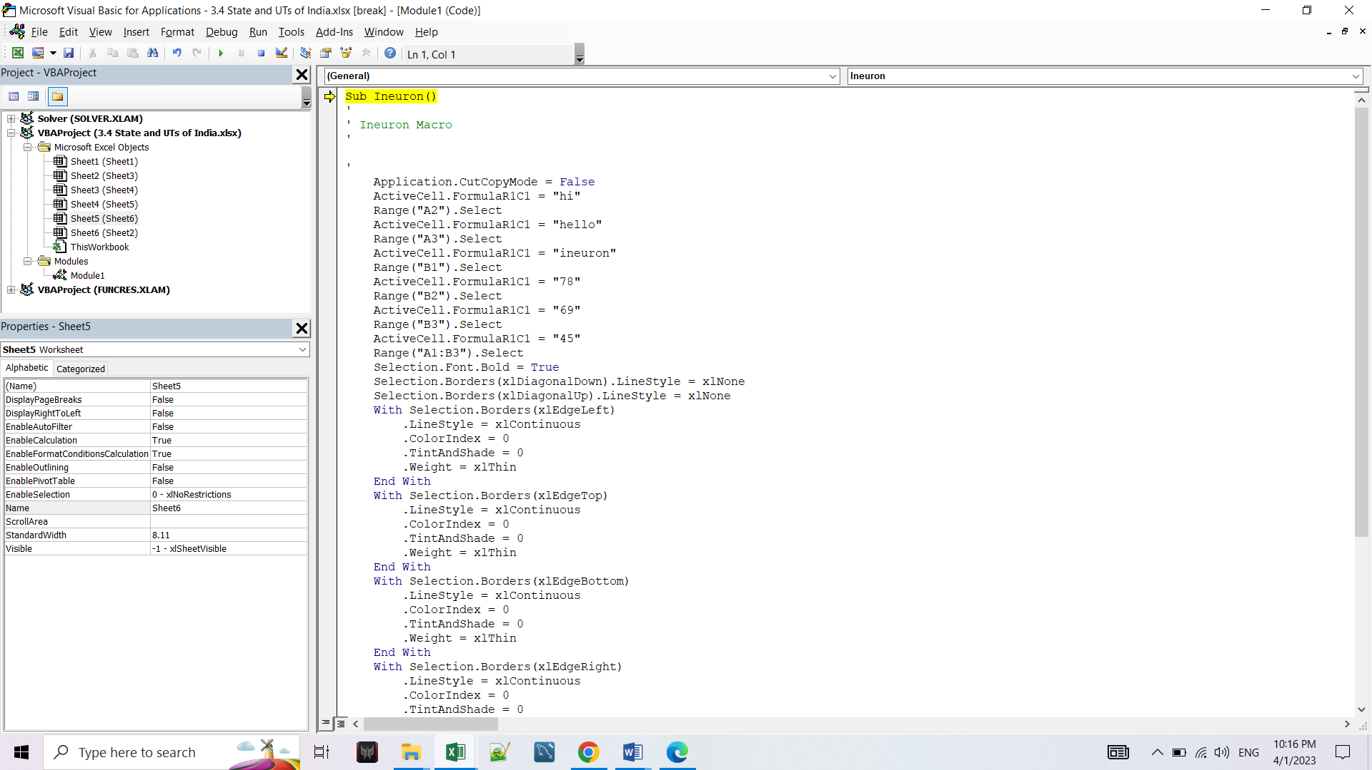

1. What do you mean when we say VBA Editor?

Ans. Writing the Code in VBA Editor.

All of the Office applications have a Developer tab in their ribbon. We may find it hidden usually. We need to enable it through the settings option. We are more focused on the usage and application of Microsoft Excel here. But it is almost the same for any other Office application. Nevertheless, here is a demonstration of enabling the tab, using modules and running a sample code to show you how it works.

* Inserting Module in VBA.
* Writing and Running VBA.
* Changing Letters from Upper Case to Lower case

1. Briefly describe the interface of a VBA editor? What is properties window? And what is watch window? How do you display these windows?

Ans. We can open the VBA interface by using the ALT + F11 keyboard shortcut, or we can go to the Developer tab and click on Visual Basic.

Create a Command Button

Now that we have enabled the developer tab and have some familiarity with the VBA editor, now start creating a macro by using a command button.

To place a command button on the worksheet, follow these steps:

* Go the Developer tab > Insert > ActiveX Controls > Command button.
* Drag the command button on the worksheet.

Assigning a macro to a command Button

To assign a macro to the command button, follow these steps:

* Right-click on the command buttons and select View Code.
* Add the following lines of code shown below.
* Close the VBA editor and click on the command button on the worksheet. Make sure to deselect the design mode.
* Enter input and click OK. It will enter the input on cell A1.

1. What is an immediate Window and what is it used for?

Ans. Immediate Window is a small box in the Visual Basic Editor that we can use to execute a single line of code and get an instant result of that. In simple words, instead of executing code directly in Excel, we can run a macro line to what it returns. It’s quite useful when we are debugging a code.

When we open the visual basic editor (Alt+ F11), we can see the immediate window at the bottom. But, if it’s not there then we need to activate it from the edit menu, or we can also use the keyboard short key Control + G. And if we want to unlock it, click and hold the title bar and drop it and outside of the VB Editor.

**Immediate window is used to:-**

* Test problematic or newly written code.
* Query or change the value of a variable while running an application. While execution is halted, assign the variable a new value as you would in code.
* Query or change a property value while running an application.
* Call procedures as we would in code.
* View debugging output while the program is running.